

International Federation of Majorettes Sport
Asian Federation of Sports Majorettes and Baton Twirling
Federation Sport Majorettes and Baton Twirling
Kyrgyz Republic

II-nd CENTRAL ASIAN CHAMPIONSHIP
MAJORETTES SPORT
&
BATON TWIRLING

07. 06. 2019
Bishkek, Kyrgyz Republic


The competition is governed by the Rulebook of IFMS for the tournament and competitions, in accordance with CENTRAL COMPETITION RULES AND REGULATIONS 2019.

- Location for competition on June 7

Sports and recreational complex “Gazprom” (Residential area "Archa Beshik")

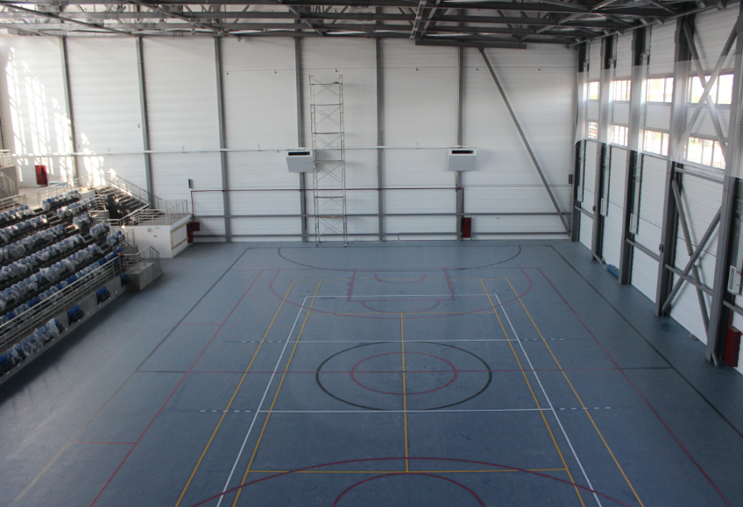

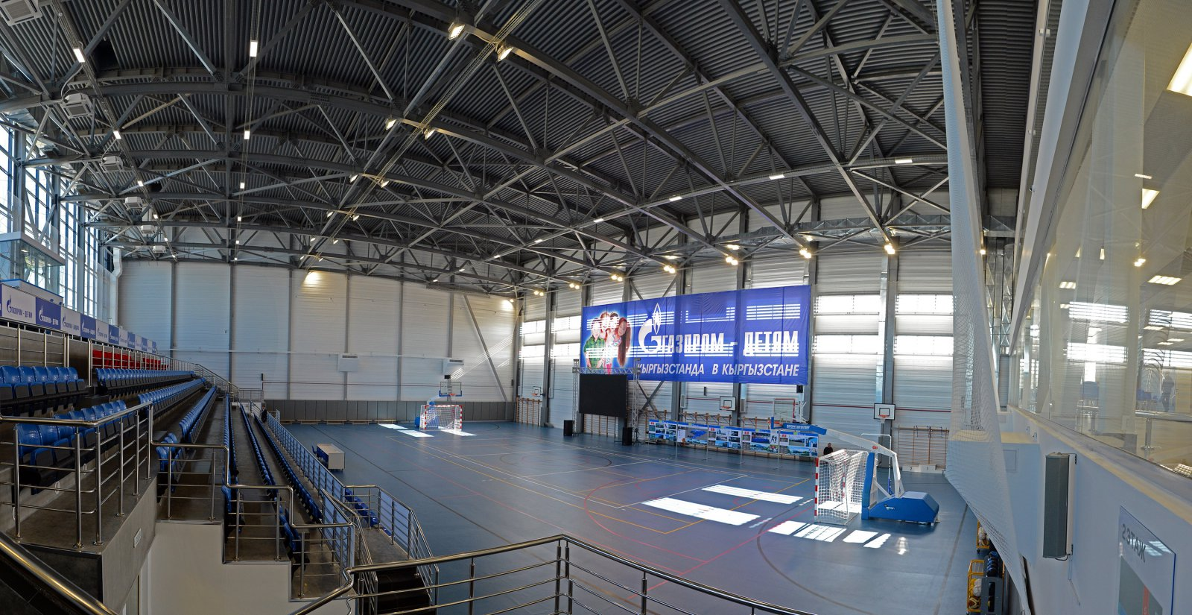

- Competition disciplines under IFMS rules

1) Stage performances solo-formations
- Solo with equipment BAT, POM, 2 BAT, FLAG
- Duo-trio with equipment BAT, POM, 2 BAT, FLAG
- Miniformation with equipment BAT, POM, FLAG, MIX, DRUM

2) Group stage performances with equipment BAT, POM, FLAG, MIX, SHOW, DRUM
4) Group stage classic majorette with equipment BAT

3) Marching parade with equipment BAT

4) Marching parade with equipment POM
5) Marching parade classic majorette equipment BAT

- Age categories
Mini Cadettes:
1. Primary 4 – 7 years: 2015, 2014, 2013, 2012

Cadettes (KAD):

1. primary 8-11 years: 2011, 2010, 2009, 2009

Juniors (JUN):

1. primary 12 -14 years: 2007, 2006, 2005
Seniors (SEN):
1. basic 15-26 years: 2004, 2003, 2002, 2001, 2000, 1999, 1998, 1997, 1996, 1995, 1994, 1993, 1991
Grand seniors:
1. from 27 year 1992

- Registration fees + entry fee

Solo 10 EUR / 850 KGS
Duo-trio 10 EUR / 850 KGS per person
Groups 100 EUR /8500 KGS per team
Groups + March 150 EUR/ 12 750 KGS per team
Miniformations 40 EUR / 3400 KGS per team

Further information:
1. Costs associated with the payment are charged to the payer, the participant.
2. Registration fee is not refundable.
3. Unintended payments will be refunded upon discretion and confirmed clearance.
4. Participant will receive an invoice (proof of payment), the billing address will be taken from the application.
- Accommodation

Hotel - from 25 EUR (per person with breakfast)
Hostel - from 15 EUR (per person)
For information/reservation please email to as_tair@inbox.ru before May 20th.
- Catering
The organizer provides catering only for registered participants upon request.
Food provisions provided only during the competition days.
For additional information please email to as_tair@inbox.ru before May 20th.
- Transfer
If you need a transfer or for any information please email to as_tair@inbox.ru before May 20th.
- Music
Majorettes should use only the music that they brought with them. Media: CDs (not more than 1 track on each medium with the name of the city and dance group).
Participants must also have their tracks copied on CD or USB.
- Registration
from e-mail: registration-dance.kg@mail.ru . The last day for the registration is May 20. The application forms should be attached.

- Entrance Fee for attendants and audience

Free entrance is available for the following groups of people:
- Teachers and heads of dance groups (during the days of their dance disciplines);
- Participants during the days of their dance disciplines;
- Children up to 7 years;
- Category 2 disabilities;
- Veterans.

Note. Free entrance is provided ONLY upon reference documents.

Ticket cost
3 euro/ 250KGS
11. Schedule

The detailed schedule will be published after the end of registration by May 20.

- Contact information

Federation Majorettes Sport and Baton Twirling Kyrgyz Republic
e-mail: okspoly.27@mail.ru

