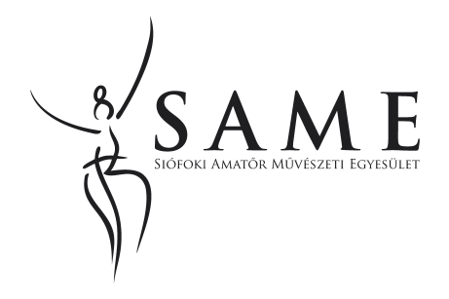
ANNOUNCING
MAJORETTES ON STAGE
COMPETITION
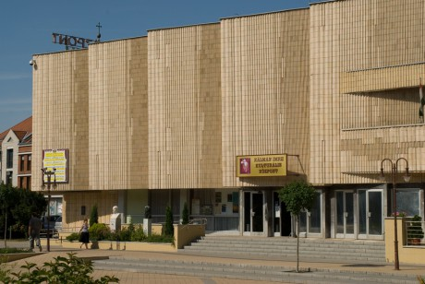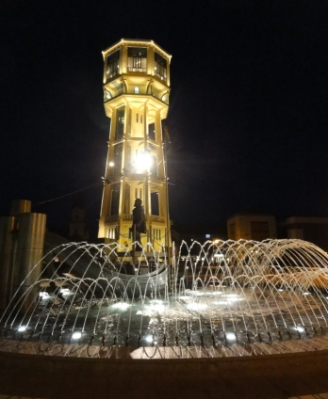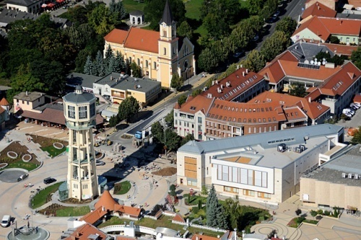
Dear Dance-teachers, Art Directors, Dear Dancers, and Majorettes!
Our organization-as a tradition-with the help of the Government of Siófok and the Kálmán Imre Cultural Centre-is going to organize the
XI. Majorettes Challange Cup Competition of Siófok
The competition is national /international , open and free of any association membership.

The date of the competition: 25. April 2015 (Saturday)
The starting time of the competition: depends of the number of participants

The place of the competition: Kálmán Imre Cultural Centre
8600 Siófok Fő tér 2.

Age groups: Mini 5-8 age
Children 9-11 age
Youth 12-14 age
Junior 15-18 age
Senior 18 age

For the classification for solos:- the date of 25.04.2015.
-the duo and trio and groups: the average age of participants.
- 2 -
Categories:
I. Solo 1 stick
II. Solo 2 sticks
III: Duó/trio 1 stick
IV. Duó/trio 2 sticks
V. Little group/ mini formation/ 4-7 person 1 stick
VI. Little group /mini formation / 4-7 person 2 sticks
VII. Big group - 8-10 person- 1 stick
VIII. Big group- 8-10 person- 2 sticks
IX. Formáció –from 11 person - 1 stick
X. Formáció –from 11 person- 2 sticks
XI. Pom-pon – solo
XII. Pom-pon – duo/trio
XIII. Pom-pon – little group /mini formation/ 4-7 person
XIV. Pom-pon – big group – 8-10 person
XV. Pom-pon – formation – from 11 person
XVI. Other categories (to use of flag, or umbrella, or veil) could be solo, duo/trio, little group big group, and formation.

Registration fees:
Solo 2.000 Ft/person
Duo/trio 4.000 Ft/production
Little group/mini formation/ (4-7 person) 8.000 Ft/person
Big groups(8 -10 person) 10.000 Ft /production
Formation (from 11 person) 12.000 Ft /production

Timeframe/time limit:
Solo , duo/trio (1 stick, 2 stick, max. 2.0, minutes)
Groups (mini, children max.3.0 minutes, all the other groups max.3,5 minutes)
The count of time is from the beginning of the music to the end of the music, including the music of marching in and the music of marching out ( if it needs music for)
Attention teachers, if there is going to be exceeded the time, the music will be stopped at the limit!
OTHER IMPORTANT INFORMATION:
There is NO solo chategory Mini age group!

There is no obligatory production, every dancer participates in their own categories.
If there is not enough production in one category, we will merge categories.
For registration: there is NO quantity limit for production.
It is important, to know, the choreographies for the productions should be made for theatre stage, not for a sport hall.
The size of the stage: 9 meter wide, 11 meter dept, height 5.5 meter
For the choreography you have to pay attention for the heights ( no required) the twirling technics is not obligatory, but it will raise the quality of the production.
The judges are nationwide recognized 3-5 professionals.
The point of view of judging:
- marching in-, marching out- of the stage, continuing after a mistake
- choreography
- technical level
- entertaining
- spectacle
The maximum points are 50 points per judge.
If there is no available of merging in categories, or ages, than the judges will make point limits, what is going to be announced at the beginning of the competition.
Dedline for registration: 30. March 2015
The registration is valid only with the proof of the payment of all registration fees.

For postal payment, please make it to:
Siófoki Amatőr Művészeti Egyesület, Fekete Pálné
8600 Siófok, Széchenyi u. 8-10. III/17

For bank transfer, please address it to: Siófoki Amatőr Művészeti Egyesület
70900141-10025884-00000000

For technical reason, there is NO registration on location!

Prizes: medals, cups, certificates,

MORE PRIZES:
Grand Prize: Group production which sticks achieves the highest points
The “City of Siófok” Challenge CUP of + 50.000Ft. prize

New Challenge Cup: Group POM-PON or OTHER categories procuction which achives the
highest ponts
The Hotel Balaton’s “Balaton” Challenge cup +20.000Ft. prize
THERE IS A VERY IMPORTANT RULE, PARTICIPANTS FROM SIÓFOK (home of the challange cup)CAN NOT WIN THE GRAND PRIZES!
Other prizes:
I. place 30.000 Ft
II: place 20.000 Ft
III. place 10.000 Ft
For the classification all the points of the same clubs or association will be counted.

Special Awards:
-Miss Majorette ribbon-soloists, from all the age groups, who achieved the highest points
(If that is a boy, than the prize goes to the next girl participant, who achieved the high points )
-Gift Package-duos from all the age groups, who achieved the highest points.

The entrance fees for the competition:
Adults 1000 Ft/ person for all day
Children under age of 12, 500 Ft./ person for all day
The participants don’t have to buy entrance tickets, so that is why we ask the teachers to count all the participants only once, not by age groups.
For each school or club receive one complementary ticket for their art director.

For the Music of the productions, it can be on CD ( your own responsibility ) or on pendrive, and one person could direct it from the technical room.

For more information:
Fekete Pálné ( organizer)
Tel: 30/540-6355,
E-mail: same.fklari@gmail.com, smsts@citromail.hu,

The registration page could be copied, kindly ask to fill out by age groups, if there is not enough space for participants, you can copy the page for more participants.

If you would like to register via e-mail, it is very important to attach the scanned copy of a proof of payment of the registration fees.

We wish you a good preparation time, and we hope we will see you on the competition.

Siófok, 10.01.2015

Best regards Fekete Pálné
President of SAME, and organizer

Jelentkezési lap(korcsoportonként töltendő) / Registration form (fill out by age groups)

Mazsorettek XI. Siófoki Vándorkupa versenye /XI. Majorettes Challange Cup Competition of Siófok

Országos/nemzetközi és nyílt
The competition is national /international , open and free of any association membership.
2015. április 25.
Siófok

1. A nevezett tánciskola/egyesület/SE csoport neve/ Name of school, club or association

…………………………………………………………………………………………...................................................................
2. A nevezett tánciskola/egyesület/SE csoport címe: / Address of school, club or association

…………………………………………………………………...……………….................................................................………

2. Művészeti vezető neve / name of the art director :…………….…………...............................................…..

tel.: …………….................................................e-mail:………...............................................................……….

3. Korcsoport/ age group:……….........……………. összesített létszáma / all participants:………………..........

Korcsoportonként küldendő! Fill out by age groups!!!!

Kategória/ Category | Előadó/előadók csoport neve  /Names of Participants | létszám  No.people | idő  time

Számlázási cím / Address to make the invoice to :………………………………………………………………………………..

(Előre megadott számlázási cím esetén a számla a regisztrációnál átvehető, utólagos számlázás mindig gondot okoz!!)
You can pick up the invoice at the registration desk

Beérkezési határidő / deadline : 30. March 2015.

Dátum / date:………………………………………..
.....................…………………………………
Igény szerint sokszorosítható! You can copy if you need Aláírás/ Signature
-2-

A csapat/klub/egyesület megnevezése / the name of a group, club, or association

:…………………………………………..……………...................................................................................................

Versenyzők összesített névsora / participants all together :

Sorszám No# | Név  Name | Születési év  Year of birth
Igény szerint sokszorosítható!
If you need you can copy it.

