Russian Sport Choreography Federation
All Russian Majorettes & Baton Twirling Federation

INTERNATIONAL OPEN CUP

5 - 6. 05. 2017

Moscow, Russia

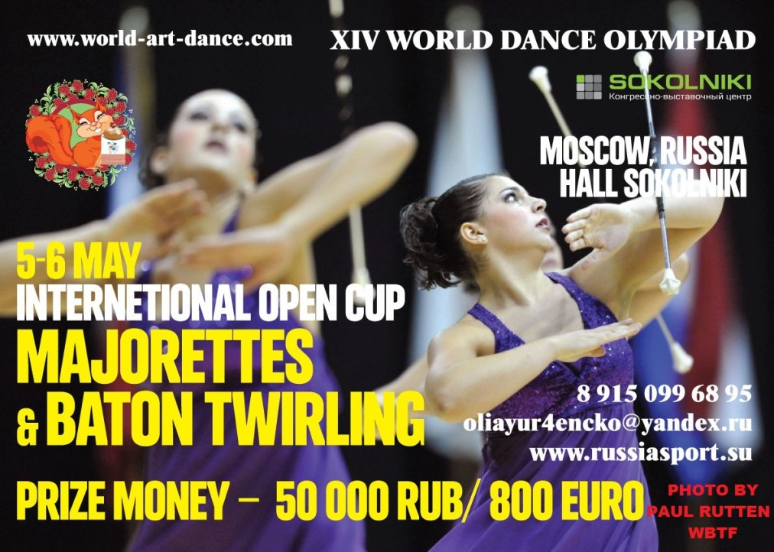

The competition is governed by the rules of RSCF, WBTF, NBTA, IFMS.

- Place of competition

Congress and Exhibition Center "Sokolniki" (The nearest metro station – Sokolniki)

05/05 - Hall 2 (Pavilion 4.1)
06/05 – Hall 3 (Pavilion 3)

- Competition disciplines

Majorettes

1) Stage performances solo-formations
- Solo with equipment BAT, POM, 2 BAT, FLAG
- Duo-trio with equipment BAT, POM, 2 BAT, FLAG
- Miniformation with equipment BAT, POM, FLAG, MIX, 2 BAT, DRUM
2) Group stage performances with equipment BAT, POM, FLAG, MIX, SHOW, DRUM
3) Marching parade with equipment BAT
4) Marching parade with equipment POM

- Contact information

All Russian Majorettes & Baton Twirling Federation
e-mail: oliayur4encko@yandex.ru
http://www.russiasport.su
https://www.facebook.com/groups/945012785520856/

- Age categories

Cadettes (KAD):

1. primary 8-11 years: 2009, 2008, 2007, 2006
2. exception granted, only to 2005 (12 years)

Juniors (JUN):

1. primary 12 -14 years: 2005, 2004, 2003
2. exception granted, only to 2002 (15 years)

Seniors (SEN):
1. basic 15 years and over: 2002, 2001, 2000, 1999, 1998, 1997, 1996, 1995, 1994, 1993, 1992, 1991
2. exception granded 1990

- Registration fees + entry fee
Groups 100 EUR
Groups + March 150 EUR
Solo 10 EUR
Duo-trio 20 EUR
Miniformations 40 EUR
Further information:
1. Costs associated with the payment are charged to the payer, the participant
2. Registration fee is not refundable
3. Unintended payments will be refunded upon discretition and confirmed clearance
4. Participant will receive an invoice (proof of payment), the billing address will be taken from the application
Payment of contributions in cash on the spot competition
- Accommodation
Information here: http://russiasport.su/accomodation
- Catering
The organizer provides catering only for registered participants.
Food provisions provided only during competition days.
Information here: http://russiasport.su/catering
- Transfer
Information here: http://russiasport.su/transfer
- Music
Majorettes should use only the music that they brought with them. Media: CDs (not more than 1 track on each medium with the name of the city and dance group).
Participants must also have their tracks copied on CD and USB.
- Registration
Application forms are available on the website: http://russiasport.su/registration
- Arrival
Main entrance to Sokolniki director’s office (between Pavilions 4 and 4а)
Information for drivers. Entry to the park territory must be paid.
There is a special technical entry for buses with participants that is available only on preliminary request. Buses and cars should be parked only out of parl territory.
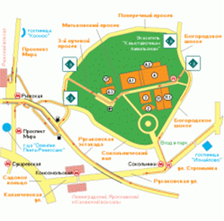
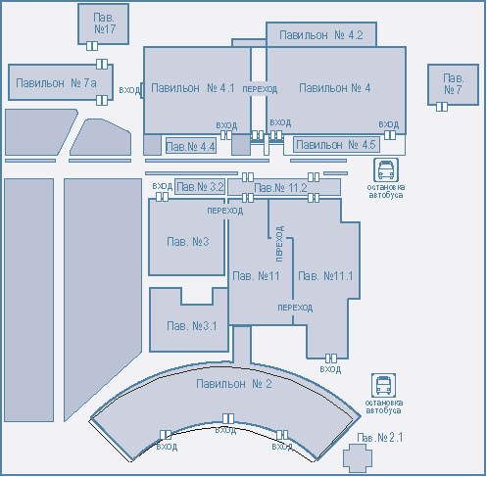
- Entrance Fee for attendants and audience

Free entrance is available for the following groups of people:
- Teachers and heads of dance groups which take part in the Olympiad (during the days of their dance disciplines)
- Participants of the Olympiad during the days of their dance disciplines
- Children up to 7 years
- Category 2 disabilities
- War participants and veterans.
- Families with many children are given 50% discount.
Note. Free entrance is provided ONLY if corresponding documents are presented.
 | Ticket cost  When buying from 1.02 to 01.04 | Ticket cost  When buying from 1.04 to 27.04 | Ticket cost  When buying on competition
5 MAY | 11 euro / 700 rub | 13 euro/ 800 rub | 16 euro/ 1000 rub | The ticket allows to be at the venue for the whole day and visit all the programmes and pavilions
6 MAY | 11 euro / 700 rub | 13 euro/ 800 rub | 16 euro/ 1000 rub

- Taking photographs and videos
Everyone who wants to take photos or videos at the Olympiad is to buy a special ticket
for 6 euro/ 350 rub for each day of the Olympiad.
- Programme (Preliminary)
05.05.2016 | 06.05.2016
BATON CADETS  • teams march  • solo  • duo-trio  • mini  • teams stage  BATON JUNIORS  • teams stage  • solo  • duo-trio  • mini  • teams march  BATON SENIORS  • teams stage  • solo,  • duo-trio  • mini  • teams march | POM-POM CADETS  • teams stage  • solo,  • duo-trio  • mini  • teams march  POM-POM JUNIORS  • teams stage  • solo,  • duo-trio  • mini  • teams march  POM-POM SENIORS  • teams stage  • solo,  • duo-trio  • mini  • teams march
2 BATON CADETS  • solo  • duo-trio  • mini  2 BATON JUNIORS  • solo  • duo-trio  • mini  2 BATON SENIORS  • solo  • duo-trio  • mini | FLAG  • Cadets  (solo, due-trio, mini, teams stage)  • Juniors  (solo, due-trio, mini, teams stage)  • Senior  (solo, due-trio, mini, teams stage)
TWIRLING | SHOW  - Cadets  - Juniors  - Senior
MIX
• Cadets (mini, teams stage)
• Juniors (mini, teams stage)
• Senior (mini, teams stage)
Medal ceremony

DRUMS
• Cadets (mini, teams stage)
• Juniors (mini, teams stage)
• Senior (mini, teams stage)

 | Medal ceremony

