Special offer for accommodation of participants
in hotel "Hollywood"

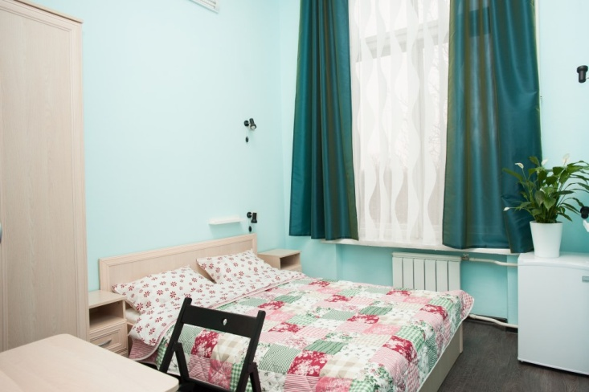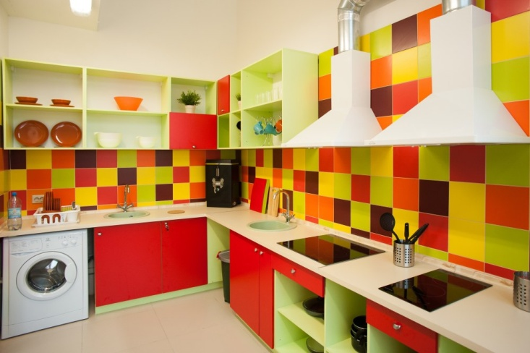

Location: Moscow, ul.Lazo 8

Nearest Metro - Perovo

1) Located within walking distance from the Metro Perovo (10-15 min., Easiest route) in a quiet place
2) When the group arrived at avtobuse- have the opportunity to free bus parking at dogovorennosti- free secure parking,
3) Security:
4) Fenced surrounding area,
5) The administrator is at the hotel 24 hours a day, according to the agreement will not let children out alone without an adult, a safe,
6) Youth, the modern interior of the hotel, designed in the style of Hollywood movies, which creates the impression of an additional holiday))
7) Modern fire safety system and round the clock surveillance.

In the hotel there is a huge resource for useful pastime
-free WiFi,
-kinoteatr with a large screen,
-Game consoles playstation,
-nastolnye games, horizontal bars,
-Large seating area, where our guests can chat, play,
-Large guest band-dining room,
-fully equipped kitchen: a cooler with hot and cold water, electric kettle, microwave ovens, cookers, washing machines, refrigerators, large wall-mounted TV, various kitchen utensils and containers, and in the immediate vicinity there is a large grocery store, "Bill"

SPECIAL OFFER:

2 guests – 20 euro for a place
3-seater – 15 euro for a place
4-seater – 10 euro for a place
6-seater – 8 euro for a place
8-seater – 8 euro for a place
10-seater – 7 euro for a place

- All rooms have:

comfortable beds with hypo-allergenic duvets, pillows, blankets, next to which there are shelves, lamps and sockets, quality linens and towels, as well as cabinets, chairs, tables, lockers with a key (the same safe service there at the reception) hung for clothing and dryers, mirrors, bedside rugs ..
-LCD TV,
-fridge,
is the height of ceilings 4.2 meters, and large panoramic windows create a pleasant impression of space and the presence of fresh air, creating a favorable atmosphere,
-6 Shower rooms, equipped with everything necessary for a comfortable showering, 10 cabins with toilets and urinals equipped with sinks, mirrors and dispensers for liquid soap, and most importantly, san / nodes are divided into male and female.

Food:

breakfast 3 euro, lunch - 5 euro, dinner - 5 euro

Applications will be accepted until April 25, 2017.
BY EMAIL: oliayur4encko@yandex.ru, indicating in the subject
"Reservation hotel « HOLLYWOOD »
The application form and fill pattern are included.

Application form for reservation:

Date of reservation - "___", the ________________2017
Please book rooms in Hotel «Hollywood»
Team name:
Leader`s name/surname:
Phone:
E-mail:

Last Name, First Name  (Latin spelling) | Date / Time of check-in | Date / Time of check-out | Accomodation type:  single, double,triple | Standard | Standard after repair | Standard Delux

Total:

Single______ Double______ Triple_______
Number of people:________________

In addition
(to be completed if necessary):
This application form is the guarantee of 100% prepayment for all services. It should be done before 26, April 2017. After 26, April 2017 if the prepayment haven`t been done, the application will be canceled.
Change and cancellation of reservation is possible no later than one day before check-in (till 17.00) by
e-mail. If you didn`t get the order confirmation during 4 running days, please repeat your demand.

