Special offers on accommodation of participants
in the hotel «Cosmos»

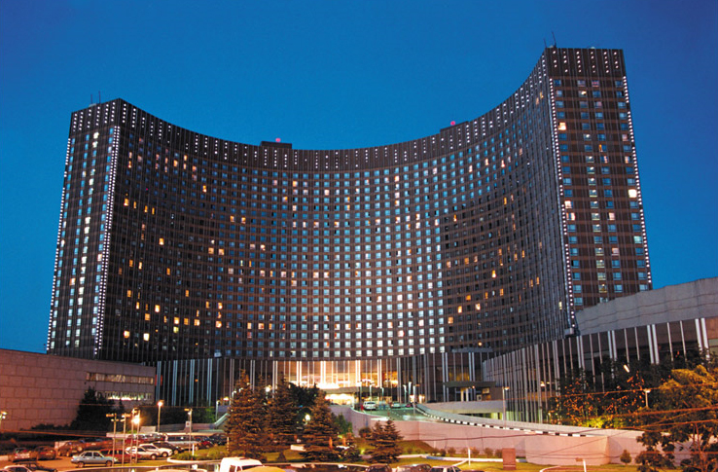

Location: The Cosmos hotel complex is located in the north-east of Moscow on one of the main streets of the city, 20 minutes from the city center.
Distance from the airports: Sheremetyevo - 35 km, Domodedovo - 55 km, Vnukovo - 40 km. Railway station: Riga - 4 km.

SPECIAL OFFER:
(Price is per room + breakfast)
Type of rooms | Price for room
Single (standard) | 37 euro
Double (standard) | 46 euro
Triple (standard) | 70 euro

Remarks:
• The cost of booking – 8 euro for 1 person, regardless of the number of days;

Applications will be accepted until April 25, 2017.
BY EMAIL: oliayur4encko@yandex.ru, indicating in the subject
"Reservation hotel « Cosmos »
The application form and fill pattern are included.

Application form for reservation:

Date of reservation - "___", the ________________2017
Please book rooms in Hotel «Holiday Inn»
Team name:
Leader`s name/surname:
Phone:
E-mail:

Last Name, First Name  (Latin spelling) | Date / Time of check-in | Date / Time of check-out | Accomodation type:  single, double,triple | Standard | Standard after repair | Standard Delux

Total:

Single______ Double______ Triple_______
Number of people:________________

In addition
(to be completed if necessary):
This application form is the guarantee of 100% prepayment for all services. It should be done before 26, April 2017. After 26, April 2017 if the prepayment haven`t been done, the application will be canceled.
Change and cancellation of reservation is possible no later than one day before check-in (till 17.00) by
e-mail. If you didn`t get the order confirmation during 4 running days, please repeat your demand.

